## **Hierarchy of Java Exception**

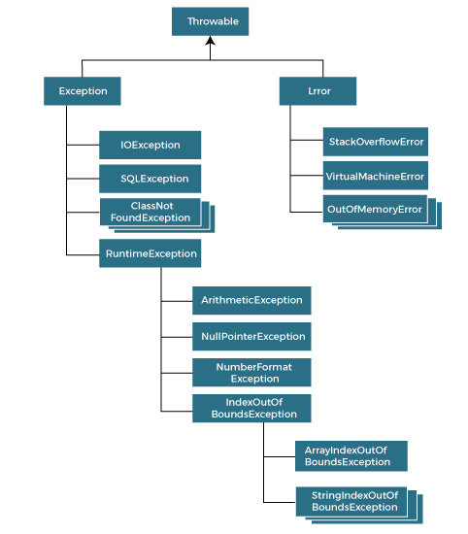

Types of Java Exceptions

1. Checked Exception
2. Unchecked Exception
3. Error

## **Exception Keywords**

try

catch

finally

throw

throws

public class Excepttry{

  public static void main(String args[]){

   try{

      int data=100/0;

   }catch(ArithmeticException e){System.out.println(e);}

   //rest code of the program

   System.out.println("rest of the code...");

  }

}